# 

Year 3/4 newsletter

Welcome back!

We hope you all had a wonderful break. We are very excited to begin the new term and start all the hard work, whilst having lots of fun. If you have any concerns at all, please do not hesitate to contact a member of the Year 3/4 team. We are happy to help. We are really looking forward to working with you to make sure that your child fulfils their potential and has the best learning experience. The best help you can give is to make sure your child attends every day on time. Attending every day enables your children to build upon their learning and further their understanding. Every school day is planned to help your child to achieve, so excellent attendance is vital. Please also ensure that your child has a healthy breakfast e.g. cereal, with lots of early nights, to ensure they can concentrate fully and give their best.

**States of Matter**

***(chemistry)***

This term children will be learning compare and group materials together, according to whether they are solids, liquids or gases. They will observe that some materials change state when they are heated or cooled, and measure or research the temperature at which this happens in degrees Celsius (°C), Children will also identify the part played by evaporation and condensation in the water cycle and associate the rate of evaporation with temperature





**English:**

Year 3/4 will be using ‘Journey to the Centre of the Earth’ as the main text for their English and Guided Reading lessons this term.

Year 3/4 will have a go at writing their own **‘explanation text’** followed by an **‘adventure narrative’**

They will be learning how to:

* Use a variety of sentence openers correctly
* spell words with prefixes and suffixes correctly
* spell words with prefixes and suffixes correctly and words from the first part of the Y3/4 wordlist.
* Organise their work into paragraphs
* Edit and improve their work

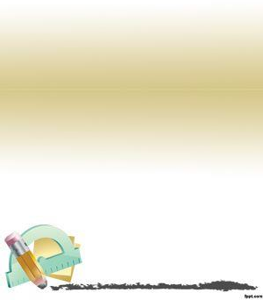

This term, we will begin by recapping knowledge from the previous year and ensuring that we a fully secure before moving on to the following maths strands:

* Fractions
* Decimals

Multiplication is vital for the year 4s this year as in June, they will be sitting their Multiplication Tables Check. We will revisit previous year’s times tables (5, 10, 2, 3, 4, 8) and develop on to our 6, 7, 9 and 12 times tables.

You can help your child succeed, increase their confidence and knowledge of times table and division facts by practising them daily. Every child has access to TTRS- a fantastic maths website which allows children to practise their tables. Please encourage them to use this daily.

**Key vocabulary**: numerator, denominator, half, quarter, whole, tenths, part, divide, convert.

**Key vocabulary**

matter

volume

solid

liquid

particle

structure

* **Matter**
* **Melting**
* **Melting point**
* **Solid**
* **State of matter**
* **Temperature**
* **Thermometer**
* **Water cycle**
* **Matter**

temperature

freezing

melting

heat energy

gas

compress

* **Melting**

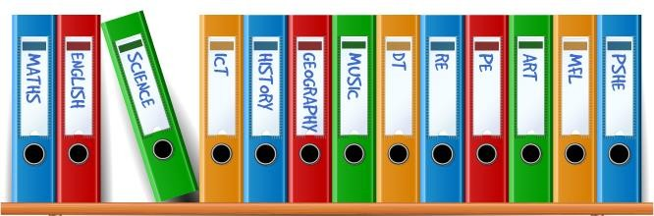

**Geography**– Our topic this term is all about Volcanoes.

**PE** – Pe this term will focus on tennis. We will master basic movements including running, jumping, throwing and catching and begin to apply these in a range of activities. The children shall develop balance, agility and coordination, and begin to apply these in a range of activities.

**PSHE**- Our topic in PSHE this term is ***How are we similar and how are we different?*** Pupils will be able to identify how people are similar and how they are different and be able to describe and use the appropriate language to use when talking about gender/sex and race/religion. Pupils will be able to apply their learning of differences to show respect to people who are different to them

**Music –** In music this term, we will be focusing on singing and the structure of songs. We will also be continuing with our glockenspiel lessons with Mrs Durrans.

**Art***–* In art this term, we shall consider ***How are imaginary animals depicted in art?*** Students will be able to explore how imaginary creatures have been depicted as story illustrations and about their historical and cultural significance. They will create artwork depicting imaginary creatures, using drawing and collage. Students will be able to evaluate and appraise their own and others’ imaginary creature artwork



**Things to remember:**

PE is on a Monday afternoon. Please ensure children have their kit every week.

Planners should be handed in every day. Please record in here when your child has read at home and sign weekly.

Useful websites:

[www.ttrs.com](http://www.ttrs.com)

<https://freckle.com/en-us/>

E-safety link: <http://www.safetynetkids.org.uk/>



April 5th – Parents Evening

April 7th – Parents Evening

April 8th - School closes

**Reading** – Year 3 and 4 pupils should be reading for at least 15 minutes every day. When reading with your child, encourage them to sound out tricky words using their phonics and discuss any unfamiliar vocabulary. Stop them regularly, to check their understanding, as this will support them with their learning. Some questions you could ask: what are the characters thinking/feeling? How do you know? Children will take an Accelerated Reader quiz following completion of their book. Achievement Points will be rewarded for children scoring 80% or more.

**TTRS**- Children should be accessing TTRS for at least 10 minutes every day- we are monitoring progress daily and giving out lots of achievement points so please continue to support this at home.

Thank you.