# 

Year 6 newsletter

Welcome back everyone! We are now half-way through the school year and only have three terms left here at Trinity Academy St Peters. This term we have lots of exciting lessons to look forward to, including cooking a Mexican meal. Our achieve sessions will continue on Thursdays after school and we would like to see as many children attend as possible.

As always, if you have any concerns or queries contact a member of the Year 6 team alternatively you could contact our home school liaison worker, Mrs Melanie Crawshaw through the school office or she is usually outside before or after school.

In Year 6, Term 3 some of the objectives we will be working on are: understanding how fossils are formed, evaluating the evidence provided by fossils, analysing evidence in order to create relevant scientific questions and understanding how parents’ characteristics are inherited.



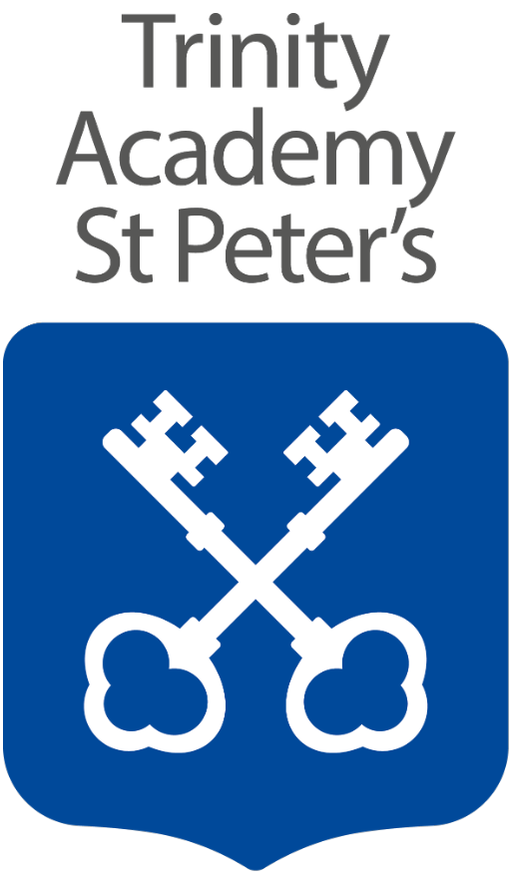

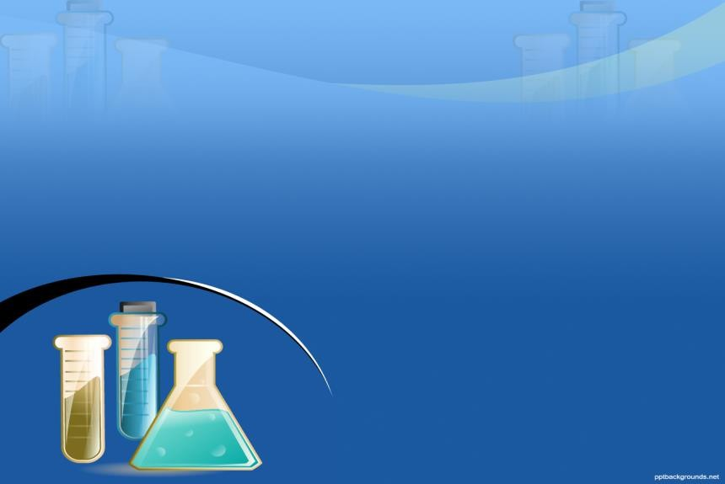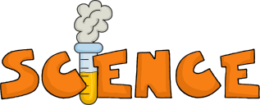

**English:**

To begin this term, we will be studying poems from The Lost Words and The Lost Spells. these link with our geography.

Following this we will be studying the book Darwin’s Dragons. This is an engaging novel which mixes an adventure story with discovery and magic. It is steeped in science, and it blends fantasy fiction with historical fact. It links with the science topic on evolution and inheritance and with the geography topic on the environment. It also aligns with one of our key themes of resilience and courage.

During this term we will be writing a non-chronological report and writing our own fiction from different viewpoints.

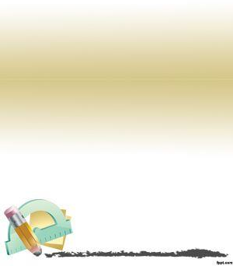

Throughout Year 6, the children will be working on groups of objectives linked to the following strands:

• Number and Place Value

• Addition and Subtraction

• Multiplication and Division

• Fractions and Decimals

• Measurement

• Geometry (Shape and Space)

• Statistics (Data Handling)

This half term, we will be completing our work on algebra and moving onto working with perimeter, are and volume. This will be followed by work on ratio, which we will move on to before half term.

As with most strands of maths, it is imperative that children have a secure knowledge of their times tables. This has improved in our class this term but children still need to practise on TTRockstars as well as completing their homework on Freckle Maths.

**Key words:**

substitution, formulae, perimeter, area, volume, ratio, proportion

**Key words:**

genetic, characteristics, geology, tectonics, organisms

* **Matter**
* **Melting**
* **Melting point**
* **Solid**
* **State of matter**
* **Temperature**
* **Thermometer**
* **Water cycle**
* **Matter**
* **Melting**
* To know the idea of the Earth’s rotation and use this to explain day and night and the apparent movement of the sun across the sky

**Reading** – Year 6 pupils should be reading for at least 15 minutes every day. When reading with your child, encourage them to discuss any unfamiliar vocabulary. Stop them regularly, to check their understanding, as this will support them with their learning. Some questions you could ask: what are the characters thinking/feeling? How do you know? Children will take an Accelerated Reader quiz following completion of their book. Achievement Points will be rewarded for children scoring 80% or more.

**TTRS**- Children should be accessing TTRS for at least 10 minutes every day- we are monitoring progress weekly and giving out lots of achievement points so please continue to support this at home.

**Freckle Maths –** Weekly homework will be set on Freckle Maths

Thank you.

**Geography** – Our topic is based on the enquiry question, ‘Are we damaging our world?’ By the end of term children will be able to: identify countries and geological features of those countries using maps atlases and globes, describe and understand key aspects of the distribution of natural resources including energy, minerals and water and apply their knowledge through using fieldwork to observe, measure, record and present the human and physical features in the local area using a range of methods, including sketch maps, plans and graphs, and digital technologies.

**PE** – Hockey - Children will further develop their dribbling by looking at the Indian dribble and will also develop their attacking and defending tactics in hockey. Children will be able to put of these skills into practise in games.

**PSHE**- This term we will be learning about and discussing what it means to be attracted to someone, describe what sexuality and gender is and to apply these to different scenarios.

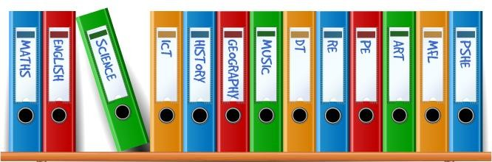

**Things to remember:**

PE is on a **Friday** afternoon. Please ensure children have their kit every week.

Planners should be brought in every day. Please record in here when your child has read at home and sign weekly.

Useful websites:

[www.ttrs.com](http://www.ttrs.com)

E-safety link: <http://www.safetynetkids.org.uk/>



Wednesday 2nd March - Y5/6 football tournament at Ryburn

Thursday 3rd March - World book Day

Friday 4th March - All classes on local tennis trip

Monday 14th March - Y6 SATs parents’ information evening

Friday 8th April - School closes for Easter